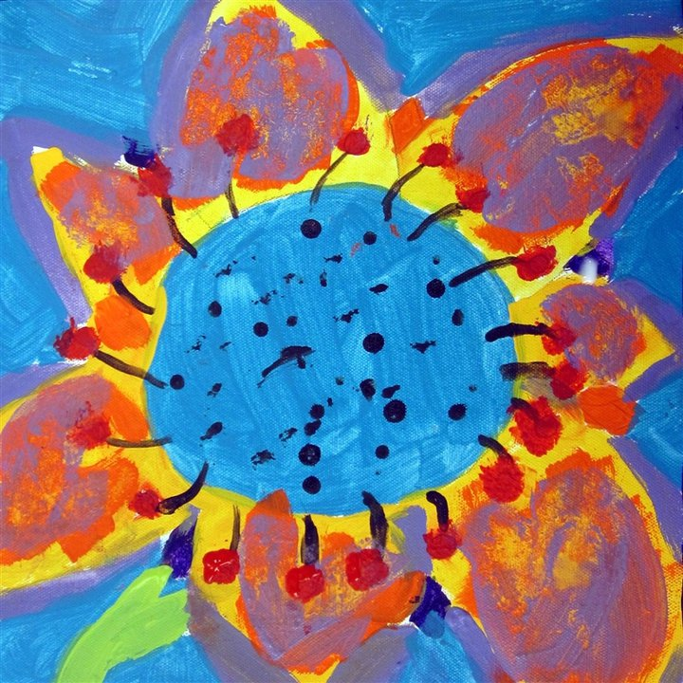
Tween
Art Camp
@Hamlin Library

June 15, 16, 18, 19
For students entering grades 5, 6 & 7 Cost is $30 per child
9am – 2pm* at Hamlin Library
Pre-registration and payment is required by May 29th and is not-refundable. Class size is limited to 12 students.
Students learn about famous artists while creating projects based on styles and theories practiced by those artists. Participants should bring a packed lunch (*except on Friday – session ends at noon). The Camp Art Show Reception/Opening will be June 19th at 11am
Call the library at 887-9262 for additional information.
Please return this registration with the camp fee by May 29th to:
Hamlin Memorial Library
P.O. Box 422
123 South Mechanic Street
Smethport, PA 16749

Tween Art Camp
June 15, 16, 18 & 19, 2015
Name:__________________________ Grade in Sept._____
Parents Name:____________________________________
Parents/Guardians Address:__________________________
_________________________________________________
Phone________________ Email______________________
Allergies or concerns staff should be aware of___________
_________________________________________________
Permission to photograph:
I, ___________________________________ am the legal guardian of _____________________________. I understand that the Hamlin Memorial Library (HML) may photograph an event or activity in which my child is participating. I give permission for HML to use photographs with my child included for the purpose of promoting the library and its services.

