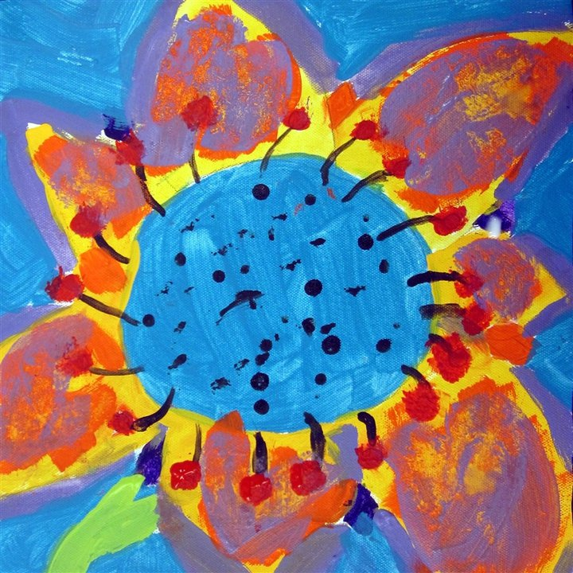
Kids Art Camp
@Hamlin Library
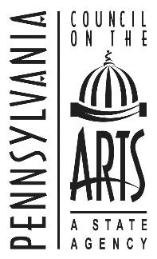
June 8th – 12th
For students entering grades 2, 3 & 4 Cost is $30 per child
9am – noon at Hamlin Library
Pre-registration and payment is required by May 29th and is not-refundable. Class size is limited to 10 students.
Students learn about famous artists while creating projects based on styles and theories practiced by those artists. Participants should wear comfortable clothing. The Camp Art Show Reception/Opening will be June 12th at 11am
Call the library at 887-9262 for additional information.
Please return this registration with the camp fee by May 29th to:
Hamlin Memorial Library
P.O. Box 422
123 South Mechanic Street
Smethport, PA 16749

Kids Art Camp
June 8 – 12, 2015
Name:__________________________ Grade in Sept._____
Parents Name:____________________________________
Parents/Guardians Address:__________________________
_________________________________________________
Phone________________ Email______________________
Allergies or concerns staff should be aware of___________
_________________________________________________
Permission to photograph:
I, ___________________________________ am the legal guardian of _____________________________. I understand that the Hamlin Memorial Library (HML) may photograph an event or activity in which my child is participating. I give permission for HML to use photographs with my child included for the purpose of promoting the library and its services.

